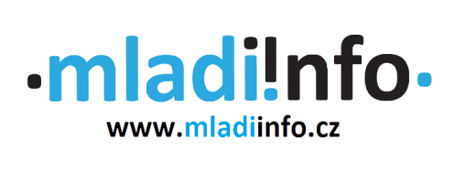

Project application form

Name of the project: EuroAsia – Acces the volunteering game (E+ youth exchange)
Date: 18/10/2021 – 25/10/2021
Venue: Dolný Kubín, Slovensko
Organisations: Mladiinfo Slovensko, Mladiinfo ČR, Mladiinfo International, ADICE (FR), Associazione Vicolocorto (IT)

Programme:

7 days long youth exchange will focus on following topics:

- volunteer and his/her role
- volunteering values
- self-development and self-tracking techniques
- how to solve the problems in your own community
- application process for European Solidarity Corps
- hosting organisations in Asia
- cultural exchange among European participants

Sending organisation: Mladiinfo ČR

Contact:
Kristýna Wagnerová
kristyna@mladiinfo.cz

Thuy Linh Mai
linh@mladiinfo.cz

First Name
Surname
Date of birth
Your organisation and your role
About your personal and professional background
Motivation to participate (Please briefly describe why do you want to participate on the exchange.)
What is your level of English?
Have you ever been to any Erasmus+ project before? Which one?

Special requirements (diets, medication, allergies, …)

Your email
Phone number
Emergency contact (name, phone number, e-mail)

