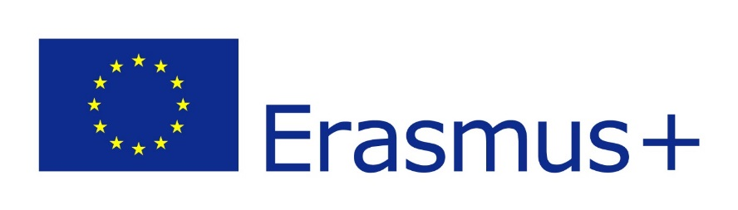
Registration for Studies within the Programme ERASMUS+ in Europe in ac. year 2023/2024

You can apply for the study exchange programme Erasmus+ by filling in this questionnaire https://forms.office.com/e/uFdEs1Ca1Y by 21.2.2023, 23:59. A part of the application is also an uploading of the documents mentioned below as 1 single pdf file.
- Transcript of study records (from UIS, and/or Diploma Supplement) + study average
- Motivation letter in English (+ in language of instruction at the host university)
- Language certificate (language of instructions at the host university, not needed for native speakers) – can be submitted later
- Consent (confirmation) of your thesis supervisor (the form available at the webpages of the faculty in “Erasmus+” section; may be substituted by e-mail confirmation) – can be submitted later
Interview in the language of instruction at the host university, AND also in the official language of the host country in most cases are part of the selection procedure. Interviews will take place on 28th Feb 2023, according to the current situation online or in person, you will get an invitation on time.
Important – registration is possible only to 1 university (it’s allowed to have another 1 as “back-up” in case of lack capacity).
- We also want to encourage PhD students, who can register for Erasmus+ study stay and use this period as an international internship (3 months as minimum).
- In case you’ve already passed Erasmus study stay, YOU CAN REGISTRER AGAIN!! (up to 12 months of financial support from the Erasmus+ programme in one study cycle)
- You can find more information at the webpages of the faculty, or you can send me an e-mail to hummelova@ftz.czu.cz.
- Information about language requirements (certificate type) and courses offer are available at the webpages of the host universities.

