Doctoral Degree Board / Oborová rada
Doctoral study programme:
Tropical Agrobiology and Bioresources Management
prof. RNDr. Pavla Hejcmanová, Ph.D. – guarantor of the programme
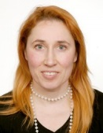 | Keywords: biodiversity conservation and protected areas, resource ecology: soil-plant-animal interactions, processing and interpretation of biological data, management of research  Member of Wildlife Management and Conservation Research Group
CONTACT
prof. Ing. Jan Banout, Ph.D.
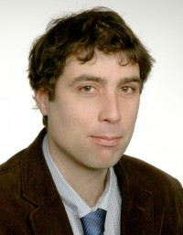 | Keywords: food processing, food security, renewable energy, appropriate technology, rural development, developing countries  Member of Food Security Research Group and Laboratory of Food Processing Technologies
CONTACT
doc. Francisco Ceacero Herrador, Ph.D.
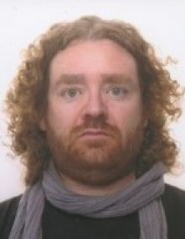 | Keywords: Practical Animal Handling, Sampling and Processing, Animal Nutrition and Feeding, Human-Wildlife Conflict  Member of Animal Physiology and Behaviour Research Group
CONTACT

prof. Ing. Bohdan Lojka, Ph.D.
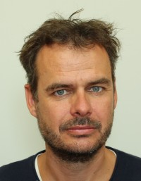 | Keywords: agroforestry, conservation of biodiversity, tree domestication, tree population genetics  Member of Tropical Biodiversity Research Group
CONTACT
Ing. Olga Leuner, Ph.D.
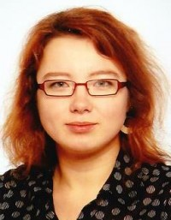 | Member of Food Security Research Group and Capacity Building & Agricultural Development Team
CONTACT
prof. RNDr. Irena Valterová, CSc.
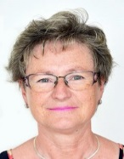
CONTACT
prof. Mgr. Ing. Markéta Sedmíková, Ph.D.
CONTACT
doc. Ing. Jaroslav Havlík, Ph.D.
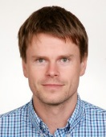
CONTACT
doc. Ing. Pavel Klouček, Ph.D.
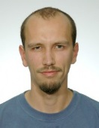
CONTACT
Ing.Martin Kulma Ph.D.
CONTACT
prof. RNDr. David Honys, Ph.D.
CONTACT

prof. Lukáš Kratochvíl, Ph.D.
CONTACT

doc. Tersia Needham, Ph.D.
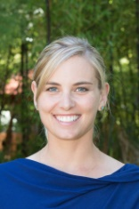
CONTACT

RNDr. Jiří Černý, Ph.D.
CONTACT

